**RALPH VAESSEN - SAAR**

.

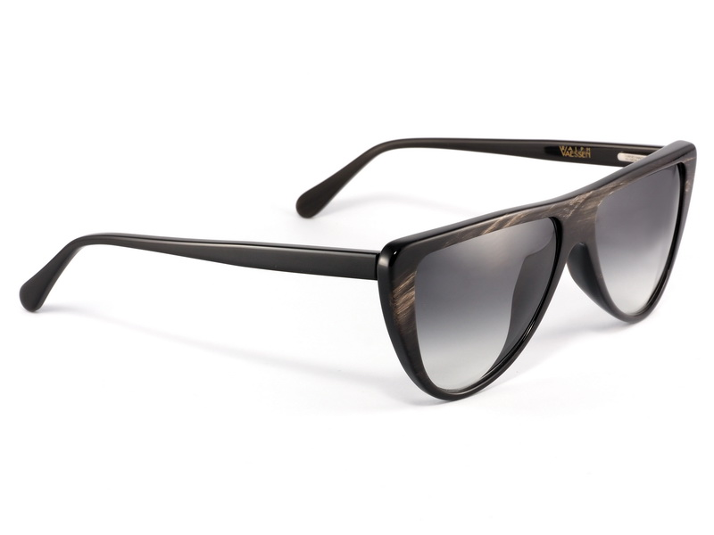

PRICES : 26.500.000VND

## Specifications

* **Shape:** Rectangle
* **Material:** Plastic
* **Hinge:** Regular Hinge
* **Rim:** Full Rim
* **Temple:** Skull
* **Bridge:** Single Bridge
* **Gender:** Male
* **Age Group:** Adult
* **Case:** Case included.
* **Manufacturer’s Warranty:** 2-year warranty.
* **Country:** Italy
* **Category:** In Stock
* **Product Group:** Prescription Sunglasses
* **Trim:** Visible logo.
* **Year:** 2017